Database Schema:
ElectionMaster (ElectionSerialNo, ElectionDate, Type, TotalNumDivisions, TotalRegVoters, LastDateToVoterRegister, LastDateCandidateNominate, LastDateToDeclareResult)
ElectoralDivision (DivisionName, TotalRegVoters, CurrMember)
ElectoralDivisionHistory (DivisionName*, ElectionSerialNo*, HistoricRegVoters)
ElectionEvent (ElectionEventID, TotalVoters, VotesCast, VotesReject, VotesValid, ElectionSerialNo*, DivisionName*, Two-Candidate-PrefWinnerCandidateID*, WinnerTally, Two-Candidate-PrefLoserCandidateID*, LoserTally)
Candidate (CandidateID, Name, ContactAddress, ContactPhone, ContactMobile, ContactEmail, PartyCode*) Contests (ElectionEventID*, CandidateID*)
PoliticalParty (PartyCode, PartyName, PartyLogo, PostalAddress, PartySecretary, ContactPersonName, ContactPersonPhone, ContactPersonMobile, ContactPersonEmail)
VoterRegistry (VoterID, FirstName, MiddleNames, LastName, Address, DoB, Gender, ResidentialAddress, PostalAddress, ContactPhone, ContactMobile, ContactEmail, DivisionName*)
Ballot (BallotID, ElectionEventID*)
BallotPreferences (BallotID*, CandidateID*, Preference)
IssuanceRecord (VoterID*, ElectionEventID*, IssueDate, Timestamp, PollingStation)
PrefCountRecord (ElectionEventID*, RoundNo, EliminatedCandidateID*, CountStatus, PreferenceAggregate)
PreferenceTallyPerRoundPerCandidate (ElectionEventID*, RoundNo*, CandidateID*, PreferenceTally)

- Three tables that are expected to be extremely large and are expected to grow over time.
VoterRegistry
CREATE TABLE VoterRegistry (
VoterID INT, = 4 bytes
FirstName VARCHAR(50), = 50 bytes
MiddleNames VARCHAR(50), = 50 bytes
LastName VARCHAR(50), = 50 bytes
Address VARCHAR(200), = 200 bytes
DateofBirth DATE, = 3 bytes
Gender VARCHAR(10), = 10 bytes
ResidentialAddress VARCHAR(200), = 200 bytes
PostalAddress VARCHAR(200), = 200 bytes
ContactPhone VARCHAR(15), = 15 bytes
ContactMobile VARCHAR(15), = 15 bytes
ContactEmail VARCHAR(100), = 100 bytes
DivisionName VARCHAR(100), = 100 bytes
ElectionEventID BIGINT = 8 bytes
);
Estimated initial table size = 4 + 50 + 50 + 50 + 200 + 3 + 10 + 200 + 200 + 15 + 15 + 100 + 100 + 8 = 1005
2013 2016 Growth Rate
2013: 15,925,415 2016: 16,504,325
Total Growth = Population 2016 ​– Population 2013 ​= 16,504,325 − 15,925,415 = 578,910
$$Growth Rate 2016=\left(\frac{578,910}{15,925,415}​\right)×100≈3.63\%$$
2016 2019 Growth Rate
2016: 16,504,325 2019: 16,934,139
Total Growth = Population 2019 − Population 2016 ​= 16,934,139 − 16,504,325 = 429,814
$$Growth Rate 2019=\left(\frac{429,814 }{15,925,415}​\right)×100≈2.61\%$$
2019 2022 Growth Rate
2019: 16,934,139 2022: 17,793,140
Total Growth = Population 2022 ​– Population 2019 ​= 17,793,140 − 16,934,139 = 859,001
$$Growth Rate 2022=\left(\frac{859,001}{16,934,139}​\right)×100≈5.07\%$$
2022 2025 Growth Rate
2022: 26,013,061 2025: 27,594,464
Total Growth = Population 2025 ​– Population 2022 ​= 27,594,464 − 26,013,061 = 1,581,403
$$Growth Rate 2025=\left(\frac{1,581,403}{26,013,061}​\right)×100≈6.08\%$$
2025 2028 Growth Rate
2025: 27,594,464 2028: 29,042,054
Total Growth = Population 2028 ​– Population 2025 ​= 29,042,054 – 27,594,464 = 1,447,590
$$Growth Rate 2028=\left(\frac{1,447,590}{27,594,464}​\right)×100≈5.25\%$$
2028 2031 Growth Rate
2028: 29,042,054 2031: 30,373,698
Total Growth = Population 2031 ​– Population 2028 ​= 30,373,698 – 29,042,054 = 1,331,644
$$Growth Rate 2031=\left(\frac{1,331,644}{29,042,054 }​\right)×100≈4.59\%$$
2031 2034 Growth Rate
2031: 30,373,698 2034: 31,611,780
Total Growth = Population 2034 ​– Population 2031 ​= 31,611,780 – 30,373,698 = 1,238,082
$$Growth Rate 2034=\left(\frac{1,238,082}{30,373,698}​\right)×100≈4.08\%$$

Voter’s projection calculations for future election 2025, 2028, 2031, 2034
Voters 2025
2022: 17,793,140 * 1005 = 17,882,105,700 bytes Growth Rate 2025 ≈ 6.08%
​$Voters 2025=17,793,140+\left(17,793,140×6.08\%\right)=17,793,140+1,081,823=18,874,963$
2025: 18,874,963 * 1005 = 18,969,337,815 bytes
Voters 2028
2025: 18,874,963 * 1005 = 18,969,337,815 bytes Growth Rate 2028 ≈ 5.25%
​$Voters 2028=18,874,963+\left(18,874,963×5.25\%\right)=18,874,963+990,935=19,865,898$
2028: 19,865,898 * 1005 = 19,965,227,490 bytes
Voters 2031
2028: 19,865,898 * 1005 = 19,965,227,490 bytes Growth Rate 2031 ≈ 4.59%
​$Voters 2031=19,865,898 +\left(19,865,898 ×4.59\%\right)=19,865,898 +911,845=20,777,743$
2031: 20,777,743 * 1005 = 20,881,631,715 bytes
Voters 2034
2031: 20,777,743 * 1005 = 20,881,631,715 bytes Growth Rate 2034 ≈ 4.08%
​$Voters 2034=20,777,743 +\left(20,777,743 ×4.08\%\right)=20,777,743 +847,732=21,625,475$
2034: 21,625,475 * 1005 = 21,733,602,375 bytes

Estimated table size after 4 elections = Voters 2025 + Voters 2028 + Voters 2031 + Voters 2034 = 18,969,337,815 + 19,965,227,490 + 20,881,631,715 + 21,733,602,375 = 81,549,799,395 bytes = 81,549.799 megabytes = 81.55 gigabytes

BallotPreferences
CREATE TABLE BallotPreferencesTemp (
BallotID INT, = 4 bytes
CandidateID INT, = 4 bytes
Preference VARCHAR(50), = 50 bytes
PreferenceNumber INT, = 4 bytes
);
Estimated initial table size = 4 + 4 + 50 + 4 = 62 bytes
2025: 18,874,963 * 6 * 62 = 7,021,486,236 bytes
2028: 19,865,898 * 6 * 62 = 7,390,114,056 bytes
2031: 20,777,743 * 6 * 62 = 7,729,320,396 bytes
2034: 21,625,475 * 6 * 62 = 8,044,676,700 bytes
Estimated table size after 4 elections = 7,021,486,236 + 7,390,114,056 + 7,729,320,396 + 8,044,676,700 = 30,185,597,388 bytes = 30,185.597 megabytes = 30.18 gigabytes
IssuanceRecord
CREATE TABLE IssuanceRecord (
VoterID INT, = 4 bytes
ElectionEventID INT, = 4 bytes
IssueDate DATE, = 3 bytes
Timestamp TIMESTAMP, = 8 bytes
PollingStation VARCHAR(100) = 100 bytes
);
Estimated initial table size = 4 + 4 + 3 + 8 + 100 = 119 bytes
2025: 18,874,963 * 119 = 2,246,120,597
2028: 19,865,898 * 119 = 2,364,041,862
2031: 20,777,743 * 119 = 2,472,551,417
2034: 21,625,475 * 119 = 2,573,431,525
Estimated table size after 4 elections = 2,246,120,597 + 2,364,041,862 + 2,472,551,417 + 2,573,431,525 = 9,656,145,401 bytes = 9656.15 megabytes = 9.66 gigabytes

Conclusion
The VoterRegistry table serves as the primary demographic repository, with an estimated row size of 1005 bytes. Historical analysis from the Australian Electoral Commission (AEC) between 2013 and 2022 reveals a consistent upward trend in voter registration, with a significant surge of 859,001 new voters recorded in the 2022 cycle alone. By synthesizing these historical trends with Australian Bureau of Statistics (ABS) population projections, the data suggests a tapering but substantial growth rate, descending from 6.08% in 2025 to 4.08% by 2034. Consequently, the cumulative registry size is projected to reach approximately 81.55 GB over the next four election cycles, highlighting a critical need for proactive storage management and indexing strategies to maintain query performance.
Parallel to the registry growth, the BallotPreferences and IssuanceRecord tables represent the highest transaction volumes within the database schema. The BallotPreferences table, while smaller in row size (62 bytes), scales exponentially based on the number of candidates; assuming a baseline of six preferences per voter, this table is projected to accumulate 30.18 GB of data by 2034. Similarly, the IssuanceRecord table is estimated to reach 9.66 GB. While the individual record sizes are lean, the high cardinality and the sheer frequency of inserts during election windows position these tables as primary candidates for high-load performance bottlenecks.
Ultimately, the findings indicate that the VoterRegistry, BallotPreferences, and IssuanceRecord tables are the most logical candidates for horizontal partitioning. Partitioning these tables by DivisionName or ID or ElectionEventID is essential because they house the bulk of the system’s data volume (totaling over 111 GB projected). By segregating data into smaller, manageable segments, database administrators can significantly improve I/O efficiency, accelerate maintenance tasks like backups, and ensure that the system remains responsive even as the national electorate expands toward the 2034 projection of 21.6 million voters.

References
ABS (2023). Population Projections, Australia. [online] Australian Bureau of Statistics website, accessed 12 Sep. 2024. https://www.abs.gov.au/statistics/people/population/population-projections-australia/latest-release
‌Australian Electoral Commission. (2014). Size of the electoral roll and estimated participation rate 2013. [online] Australian Electoral Commission website, accessed 12 Sep. 2024. https://www.aec.gov.au/Enrolling_to_vote/Enrolment_stats/national/2013.htm
Australian Electoral Commission. (2016). Size of the electoral roll and enrolment rate 2016. [online] Australian Electoral Commission website, accessed 12 Sep. 2024. https://www.aec.gov.au/Enrolling_to_vote/Enrolment_stats/national/2016.htm
Australian Electoral Commission. (2019). Size of the electoral roll and enrolment rate 2019. [online] Australian Electoral Commission website, accessed 12 Sep. 2024. https://www.aec.gov.au/enrolling_to_vote/enrolment_stats/national/2019.htm
Australian Electoral Commission. (2022). Size of the electoral roll and enrolment rate 2022. [online] Australian Electoral Commission website, accessed 12 Sep. 2024. https://www.aec.gov.au/Enrolling_to_vote/Enrolment_stats/national/2022.htm
Parker, B. (2019). Calculating Growth Rates. [online] Uoregon.edu, accessed 12 Sep.2024. https://pages.uoregon.edu/rgp/PPPM613/class8a.htm.
OpenAI (2024) ChatGPT (September 2024 GPT-4) [Large language model], accessed 12 September 2024. https://chatgpt.com/share/66e68baa-3ba8-8007-8d99-0f5a4878554b

- Produce a report of total number of voters registered in each of the electoral division, consisting of the electoral division name and total number of voters only
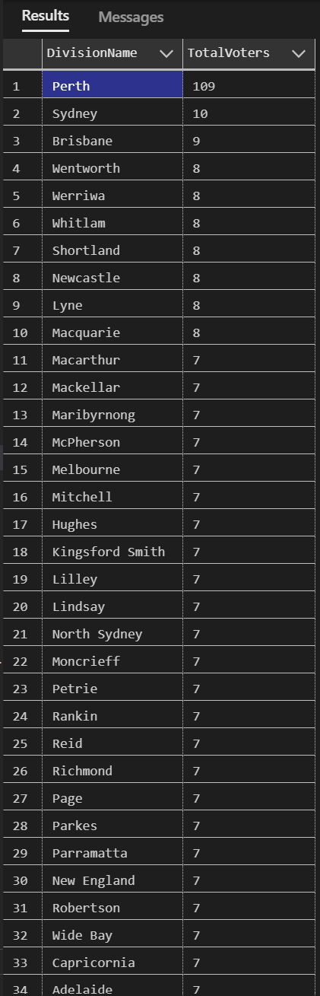
SELECT ED.DivisionName, COUNT(v.VoterID) AS TotalVoters
FROM VoterRegistry VR
JOIN ElectoralDivision ED
ON VR.DivisionName = ED.DivisionName
GROUP BY ED.DivisionName
ORDER BY TotalVoters DESC;

-- Add keys and index for VoterRegistry table
CREATE INDEX idx_VoterRegistry_DivisionName
ON VoterRegistry(DivisionName);
The SQL queries produce the list of division names and the total voters for specific divisions. This result can be produced with or without primary keys, foreign keys, or indexes. In this experiment, the user will provide differences and the usefulness of index when handling large amounts of data.
Query execution plans before index added (no keys and index)
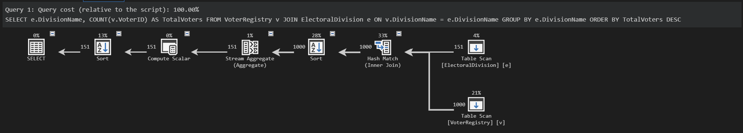
Execution Time Average: (062 + 032 + 070 + 023 + 024 + 036 + 028 + 026 + 141 + 072) / 10 = 0514 / 10 = 051.4 ms
Query execution plans after index added (full keys and index)
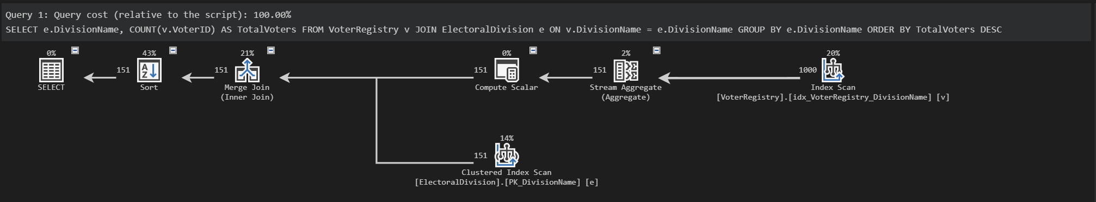
Execution Time Average: (017 + 017 + 021 + 020 + 018 + 018 + 022 + 022 + 027 + 017) / 10 = 0199 / 10 = 019.9 ms
Average Execution Time | No Index | Full Index
Join | 051.4 ms (Inner Join) | 019.9 ms (Inner Merge Join)
Operations (CPU Cost) | 0.0323497 | 0.0018051
 | 0.0156466 | 0.0062493
 | 0.001257 | 0.001257
 | 0.0018051 | 0.0003231
 | 0.0003231 | 0.0006755
 | 0.0006755 | 0
Operations (IO Cost) | 0.112613 | 0.0112613
 | 0.0186806 | 0
 | 0.0112613 | 0.00460648
 | 0.00386574 | 0.00386574
Summary
From the numbers and query plans, we can see some similarities and many differences between non-indexed tables and indexed tables. The only similarity is that the SQL server automatically uses inner join as its primary option as it is the fastest and most efficient join method for the query.
Other than that, they are quite different regarding execution time and computing cost. From the average execution time, we can see quite a significant gap between non-indexed and full-indexed tables with a 30+ millisecond difference. Additionally, the execution time frequency is lower and more stable in the full-indexed table compared to the non-indexed table. This can impact significantly over time with the table size growth requiring more computational power and speed. Another major difference is the computing cost between each process. The numbers for non-indexed are closer to 1, meaning it takes more time and power to process, while for full-indexed is much closer to 0, indicating more efficiency and effectiveness because of the indexed defined for the tables.
The full-indexed process is described using the primary keys, foreign keys, and extra indexes for specific columns. In the full-indexed table, the optimiser used non-clustered index “idx_VoterRegistry_DivisionName” from the VoterRegistry table, specifically DivisionName column, for the index scan process and clustered index “PK_DivisionName” from the ElectionEvent table, specifically DivisionName column as the primary key. On the other hand, the process from non-indexed tables showing that it requires a full table scan, sorting process, and hash match which takes more time and computing process.
In conclusion, the keys and indexes in full-indexed tables can increase the efficiency in manipulating data from various tables resulting in selected data. The SQL server optimised all the indexes queried. This means that they can help the tables to seek and scan by having the column connected to the index to produce the required data and intended results for the user.

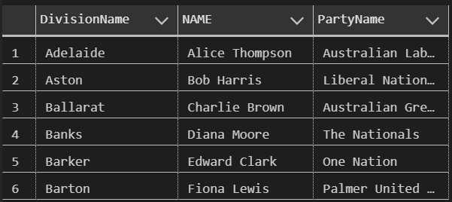
SELECT C.DivisionName, C.NAME, PP.PartyName
FROM Candidate C
JOIN PoliticalParty PP
ON C.PartyCode = PP.PartyCode
WHERE LEFT(CAST(C.ElectionEventID AS VARCHAR(11)), 8) = '20220521'
ORDER BY C.DivisionName, NEWID();

-- Add keys and index for Candidate table
CREATE INDEX idx_Candidate_DivisionName
ON Candidate(DivisionName);
CREATE INDEX idx_Candidate_PartyCode
ON Candidate(PartyCode);
The SQL queries produce the list of division names, candidate names within those divisions, and the full party name of corresponding candidates. This result can be produced with or without primary keys, foreign keys, or indexes. In this experiment, the user will provide differences and the usefulness of index when handling large amounts of data.
Query execution plans before index added (no index)
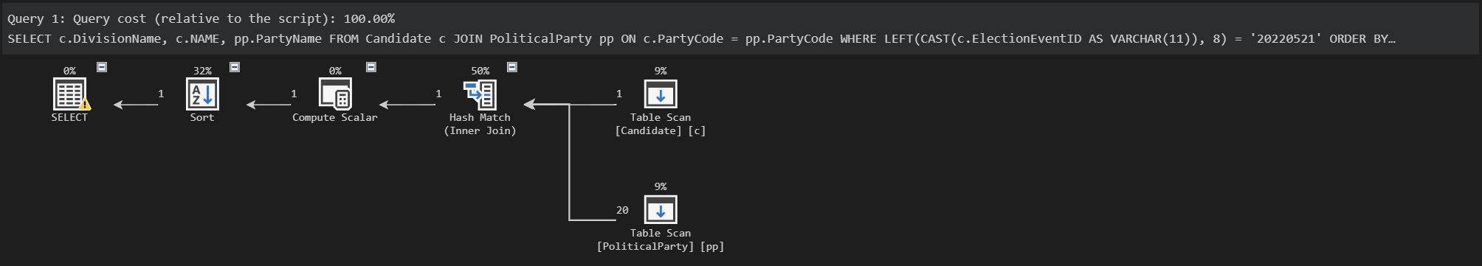
Execution Time Average: (021 + 023 + 137 + 017 + 139 + 019 + 029 + 018 + 046 + 018) / 10 = 0467 / 10 = 046.7 ms
Query execution plans after index added (full keys and index)
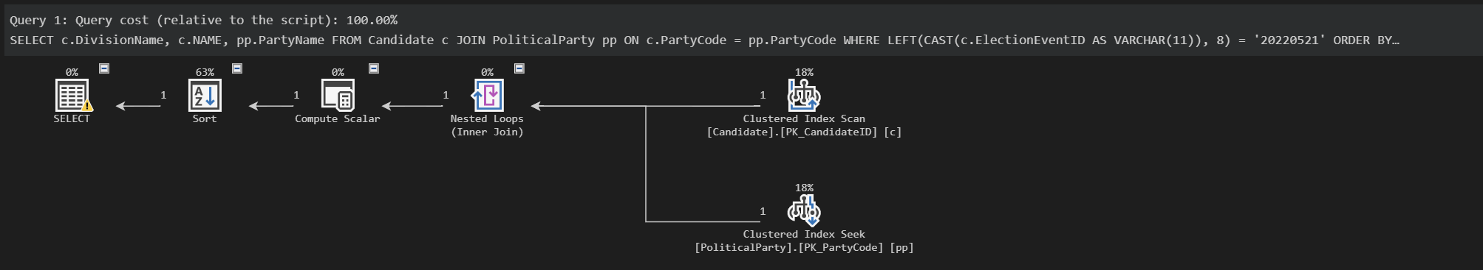
Execution Time Average: (021 + 017 + 020 + 017 + 019 + 018 + 017 + 018 + 016 + 017) / 10 = 0180 / 10 = 018.0 ms
Average Execution Time | No Index | Full Index
Join (Inner Join) | 046.7 ms | 018.0 ms
Operations (CPU Cost) | 0.0179656 | 0.000100181
 | 0.000100181 | 0.001636
 | 0.000179 | 0.0001581
 | 0.0001636 | 0.00000418
 | 1e-7 | 1e-7
Operations (IO Cost) | 0 | 0.0112613
 | 0.0112613 | 0.003125
 | 0.003125 | 0.003125
 | 0.003125 | 0
Summary
From the numbers and query plans, we can see some similarities and many differences between non-indexed tables and indexed tables. The similarity is that SQL server automatically uses inner join as its primary option as it is the fastest and most efficient join method for the query. Another similarity is that some of the operations are similar between non-indexed and full-indexed tables. This can be seen in some operations from CPU and almost all the IO operations have the same numbers.
Other than that, they are quite different in terms of execution time and some of the computing costs. From the average execution time, we can see quite a significant gap between non-indexed and full-indexed tables with a 20+ millisecond difference. Additionally, the execution time frequency is lower and more stable in the full-indexed table compared to the non-indexed table. This can impact significantly over time with the table size growth requiring more computational power and speed. Another difference is the computing CPU cost between each process. The non-indexed table uses a hash match to process which takes more CPU cost, while the full-indexed table only uses nested loops since the tables already have clustered indexes to seek and scan the tables.
From the query plan, we can see which indexes queried are utilized from the full-indexed process. In the full-indexed table, the optimiser used clustered index “PK_CandidateID” from the Candidate table, specifically the CandidateID column as the primary key, and clustered index “PK_PartyCode” from the PoliticalParty table, specifically the PartyCode column as the primary key. On the other hand, the process from non-indexed tables shows that it requires a full table scan which takes more time and computing cost. The IO costs are relatively the same since the optimiser refuses to use the non-clustered index available, such as “idx_Candidate_DivisionName” and “idx_Candidate_PartyCode”. This is because the size of the table is not big enough for the optimiser to use the indexes rather than a full table scan. Since the example only has small amounts of data, the optimiser uses a full table scan similar to non-indexed tables.
In conclusion, the keys in full-indexed tables can increase the efficiency in manipulating data from various tables resulting in selected data. The SQL server optimised only the primary keys after querying. This means that they can help the tables to seek and scan by having the column connected to the index to produce the required data and intended results for the user, but with only small data to process.
The solution for the index to be further utilised is to populate the table until a certain amount of data which can require the optimiser to use the indexes, either clustered or nonclustered indexes. In addition, the user can perform more advanced queries which can make the optimiser use the indexes to give better performance for the user. For example, the nonclustered index can be used when the query specifically selects the index so it became directly functional.

SELECT VR.VoterID, VR.FirstName, VR.LastName, VR.Address, VR.PostalAddress, VR.ResidentialAddress
FROM VoterRegistry VR
JOIN IssuanceRecord IR
ON VR.VoterID = IR.VoterID
WHERE IR.ElectionEventID NOT IN (
SELECT ElectionEventID
FROM IssuanceRecord
WHERE LEFT(CAST(ElectionEventID AS VARCHAR(11)), 8) IN ('20220521', '20190518')
);

-- Add keys and index for IssuanceRecord table
REFERENCES ElectionEvent(ElectionEventID);
CREATE INDEX idx_IssuanceRecord_VoterID
ON IssuanceRecord(VoterID);
CREATE INDEX idx_IssuanceRecord_ElectionEventID
ON IssuanceRecord(ElectionEventID);
The SQL queries produce the list of voter IDs, first name of the voters, last name of the voters, address of the voters, postal address of the voters, and residential address of the voters. This result can be produced with or without primary keys, foreign keys, or indexes. In this experiment, the user will provide differences and the usefulness of index when handling large amounts of data.
Query execution plans before index added (no index)
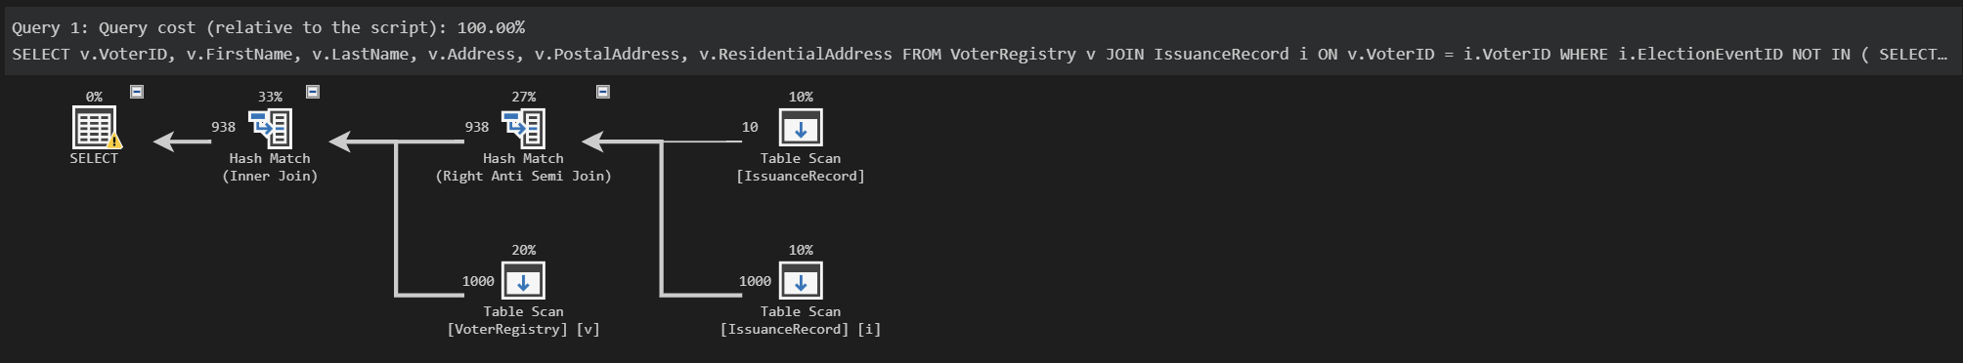
Execution Time Average: (050 + 024 + 023 + 067 + 025 + 042 + 039 + 066 + 029 + 035) / 10 = 0400 / 10 = 040.0 ms
Query execution plans after index added (full keys and index)
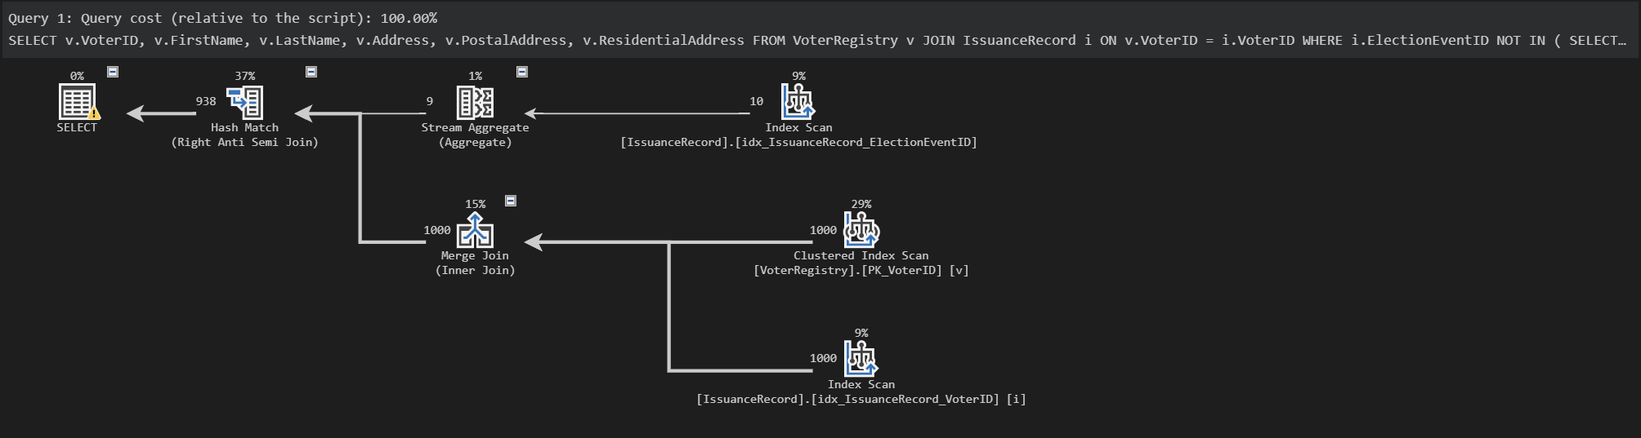
Execution Time Average: (029 + 031 + 031 + 031 + 029 + 023 + 023 + 024 + 028 + 028) / 10 = 0277 / 10 = 027.7 ms

Average Execution Time | No Index | Full Index
Join | 040.0 ms (Right Anti Semi Join + Inner Join) | 027.7 ms (Inner Merge Join + Right Anti Semi Join)
Operations (CPU Cost) | 0.0321918 | 0.0254673
 | 0.0254772 | 0.001257
 | 0.001257 | 0.0099
 | 0.001257 | 0.001257
 | 0.001257 | 0.001257
 | - | 0.00000961912
Operations (IO Cost) | 0 | 0
 | 0 | 0.0186806
 | 0.0186806 | 0
 | 0.00831019 | 0.00460648
 | 0.00831019 | 0.00460648
 | - | 0
Summary
From the numbers and query plans, we can see some similarities and many differences between non-indexed tables and indexed tables. Some computing cost operations are similar since they use full table scan for each of them and produce similar results. This is the result of the small amount of data in the table which did not utilize the proper indexing. The only difference is that the non-indexed process uses hash matches which takes more power and time, while full-indexed process uses merge join, stream aggregate, and hash match to distribute the workload and speed up the process.
Other than that, they are quite different in terms of joining method and execution time. The SQL server automatically uses the right anti semi join and inner join for non-indexed process, while indexed process uses inner merge join and right anti semi join. This indicates that these join methods are the fastest and most efficient join method for each type of table. From the average execution time, we can see quite a significant gap between non-indexed and full-indexed tables with a 10+ millisecond difference. Additionally, the execution time frequency is lower and more stable in the full-indexed table compared to the non-indexed table. This can impact significantly over time with the table size growth requiring more computational power and speed.
From the query plan, we can see which indexes queried are utilized from the full-indexed process. In the full-indexed table, the optimiser used clustered index “PK_VoterID” from the VoterRegistry table, specifically VoterID column as the primary key, nonclustered index “idx_IssuanceRecord_VoterID” from the IssuanceRecord table, specifically VoterID column as the partial key, and nonclustered index “idx_IssuanceRecord_ElectionEventID” from the IssuanceRecord table, specifically ElectionEventID column as the partial key. The process is that the tables scan based on the VoterID columns first for first iteration and join with the ElectionEventID column from IssuanceRecord table for second iteration. This is run accordingly to divide the process between indexes in parallel to fasten and ease the whole process.
On the other hand, the process from non-indexed tables shows that it requires a full table scan which takes more time and computing process. Some of the computing processes between non-indexed and full-indexed process are the same. This is because the size of the table is not big enough for the optimiser to use the indexes rather than a full table scan. Since the example only has small amounts of data, the optimiser uses a full table scan similar to non-indexed tables.
In conclusion, the keys in full-indexed tables can increase the efficiency in manipulating data from various tables resulting in selected data. The SQL server optimised only the primary keys after querying. This means that they can help the tables to seek and scan by having the column connected to the index to produce the required data and intended results for the user, but with only small data to process.
The solution for the index to be further utilised is to populate the table until a certain amount of data which can require the optimiser to use the indexes, either clustered or nonclustered indexes. In addition, the user can perform more advanced queries which can make the optimiser use the indexes to give better performance for the user.

Summary
OpenAI (2024) ChatGPT (September 2024 GPT-4) [Large language model], accessed 15 September 2024. https://chatgpt.com/share/66e68f55-a930-8007-988a-144a299fe332
TASK 3
Definitions:
Partition Pruning allows SQL Server to access only the partitions that are relevant to the query and limits the query scope to those partitions, rather than scanning the entire table. This optimizes query performance by reducing the amount of data that needs to be read.
Partition joins occur when two partitioned tables are joined on their partitioned columns. Instead of joining the entire datasets, the database engine joins corresponding partitions to reduce the amount of data being processed at once and improve efficiency.
Parallel SQL execution allows SQL Server to process multiple partitions simultaneously, distributing query workload across different processors or cores. This is done by parallelizing the execution, so each partition can be scanned or processed independently by different workers. This significantly enhances performance when dealing with large data volumes.

VoterRegistry (DivisionName)
-- Partition function based on the first character of DivisionName
CREATE PARTITION FUNCTION pfVoterRegistryDivisionName (VARCHAR(100))
AS RANGE LEFT FOR VALUES ('A', 'B', 'C', 'D', 'E', 'F', 'G', 'H', 'I', 'J', 'K', 'L', 'M', 'N', 'O', 'P', 'R', 'S', 'T', 'W');

-- Partition scheme that distributes the partitions into filegroups (in this case all into PRIMARY)
CREATE PARTITION SCHEME psVoterRegistryDivisionNameRange
AS PARTITION pfVoterRegistryDivisionName
TO ([PRIMARY], [PRIMARY], [PRIMARY], [PRIMARY], [PRIMARY], [PRIMARY],
[PRIMARY], [PRIMARY], [PRIMARY], [PRIMARY], [PRIMARY], [PRIMARY],
[PRIMARY], [PRIMARY], [PRIMARY], [PRIMARY], [PRIMARY], [PRIMARY],
[PRIMARY], [PRIMARY], [PRIMARY]);

-- Create a non-clustered index using the partition scheme
CREATE NONCLUSTERED INDEX NCIX_VoterRegistry_DivisionName
ON VoterRegistry (DivisionName)
ON psVoterRegistryDivisionNameRange (DivisionName);
The pfVoterRegistryDivisionName partition function divides the VoterRegistry table into partitions based on the first letter of the DivisionName. This results in 21 partitions, each corresponding to a specific range of starting letters from A, B, C, D, E, F, G, H, I, J, K, L, M, N, O, P, R, S, T, and W.
The psVoterRegistryDivisionNameRange partition scheme maps the table data based on the partition from pfVoterRegistryDivisionName and nonclustered index NCIX_VoterRegistry_DivisionName to ease the optimiser in accessing the partitions queried.
The partition is done using range partition since it is the only method that is available for the SQL server. Hence, this data partition is configured this way because a variety number of DivisionName containing the first letter displayed below can contain a large number of voters in the VoterRegistry table. This condition encourages the user to divide by the first letter of the DivisionName.
DivisionName First Letter | Sum of Division Names that have the same first letter
A | 2
B | 20
C | 17
D | 6
E | 1
F | 13
G | 10
H | 11
I | 2
J | 1
K | 4
L | 9
M | 19
N | 4
O | 2
P | 7
R | 6
S | 7
T | 1
W | 9
Partition Pruning
When a query filters by DivisionName, SQL Server uses the partition function to identify which partitions contain the data that matches the filter criteria. Only those partitions will be accessed to reduce the amount of data scanned.
For example,

SELECT VoterID, FirstName, LastName FROM VoterRegistry WHERE DivisionName = 'Fitzroy';

- SQL Server identifies that DivisionName query filter, declared as 'Firzroy' which corresponds to a specific partition. The optimiser scans only the ‘F' partition and prunes out all other partitions.
- The result of this partition is that targeted scanning reduces computing costs and execution time and improves query performance by focusing only on the specific subset of data.
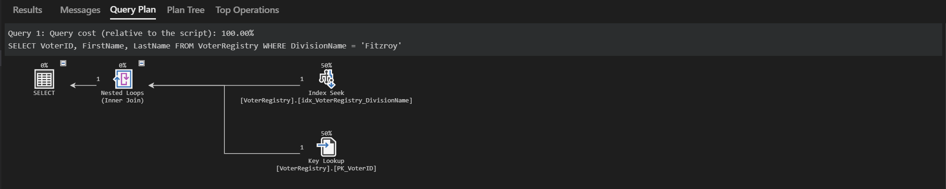
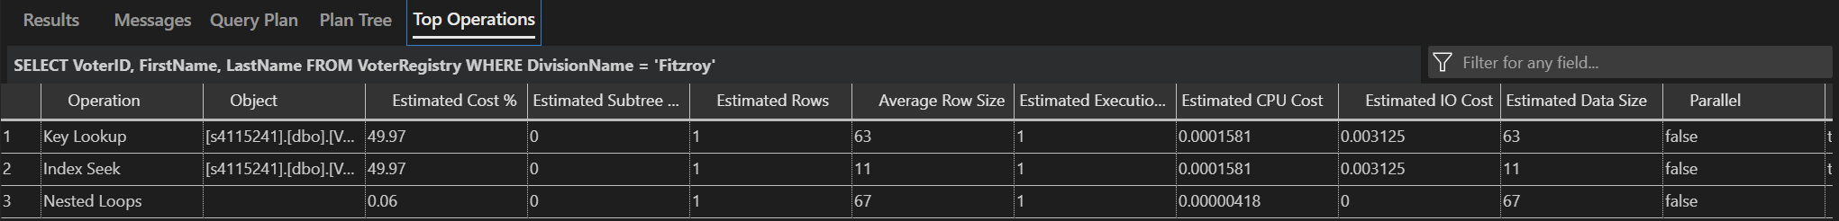
- The optimiser uses the index seek and key lookup as the partition has been implemented with reduced CPU cost and IO cost

Partition Joins
When the VoterRegistry table is joined with another table and partitioned by DivisionName, SQL Server can perform the join operation within the partitions that match the partitioning scheme. This means that only the partitions with matching DivisionName values from both tables are joined, rather than scanning all data in the tables.
For example,

SELECT VR.VoterID, VR.FirstName, VR.LastName, ED.DivisionName FROM VoterRegistry VR
JOIN ElectoralDivision ED ON VR.DivisionName = ED.DivisionName WHERE VR.DivisionName = 'Brunswick';

- SQL Server performs the join operation between VoterRegistry table and ElectoralDivision table with the DivisionName 'Brunswick' corresponding partitions. The query partitions DivisionName beginning with 'B' partition and prunes out all other partitions.
- This reduces the join workload by limiting it to matching partitions, making the join operation more efficient and faster.
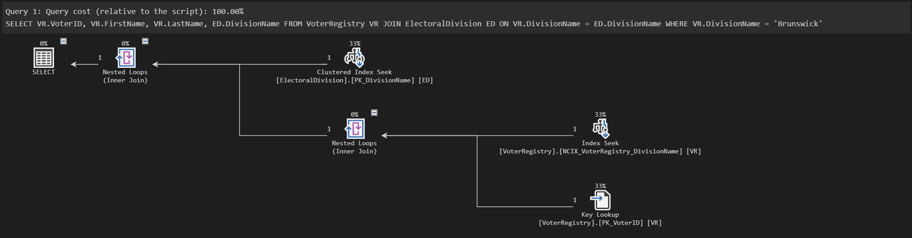
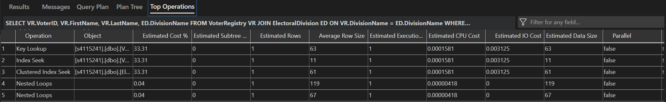
- The optimiser uses the index seek, key lookup, and clustered index seek as the partition has been implemented with reduced CPU cost and IO cost and distributed workloads.

Parallel SQL Execution
When a query filters by DivisionName and requires multiple partitions working in parallel, SQL Server can also leverage parallel execution when querying or processing multiple partitions.
For queries that span multiple partitions, SQL Server can process each partition concurrently, using multiple processors or threads to handle different partitions simultaneously.
For example,

SELECT * FROM VoterRegistry WHERE DivisionName IN ('B%', 'F%');

- SQL Server identifies that the query involves multiple partitions and executes the query in parallel, with different processors or threads working on the 'B' and 'F' partitions simultaneously.
- This parallel execution speeds up query processing by distributing the workload and reducing the time required to retrieve and process the data.
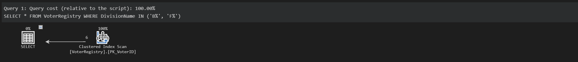
- The optimiser still uses full table scan using clustered index scan as the small amount of data in the table with similar estimated CPU cost and IO ocst

BallotPreferences (BallotID)
CREATE PARTITION FUNCTION pfBallotPreferencesBallotIDRange (INT)
AS RANGE LEFT FOR VALUES (500, 1000, 1500);

CREATE PARTITION SCHEME psBallotPreferencesBallotIDRange
AS PARTITION pfBallotPreferencesBallotIDRange TO ([PRIMARY], [PRIMARY], [PRIMARY], [PRIMARY]);

-- Create a non-clustered index on BallotPreferences using the partition scheme
CREATE NONCLUSTERED INDEX NCIX_BallotPreferences_BallotID
ON BallotPreferences (BallotID)
ON psBallotPreferencesBallotIDRange (BallotID);
The pfBallotPreferencesBallotIDRange partition function divides the BallotPreferences table into partitions based on the BallotIDs. This results in 3 partitions, each corresponding to a specific range of BallotIDs from 1-499, 500-999, 1000-1499, and 1500+.
The psBallotPreferencesBallotIDRange partition scheme maps the table data based on the partition from pfBallotPreferencesBallotIDRange and nonclustered index NCIX_BallotPreferences_BallotID to ease the optimiser in accessing the partitions queried.
The partition is done using range partition since it is the only method that is available for the SQL server. Hence, this data partition is configured this way because there is a small amount of data and to have the partitions demonstrable.
Partition Pruning
When a query filters by BallotID, SQL Server uses the partition function to identify which partitions contain the data that matches the filter criteria and prune the partitions that don’t contain relevant ballot IDs to reduce the amount of data accessed.
For example,

SELECT * FROM BallotPreferences WHERE BallotID > 1000;

- SQL Server identifies that BallotID query filter, with values more than 1000 which corresponds to a specific partition. The optimiser scans only the 1000+ partition and prunes out all other partitions.
- The result of this partition is that targeted scanning reduces computing costs and execution time and improves query performance by focusing only on the specific subset of data.
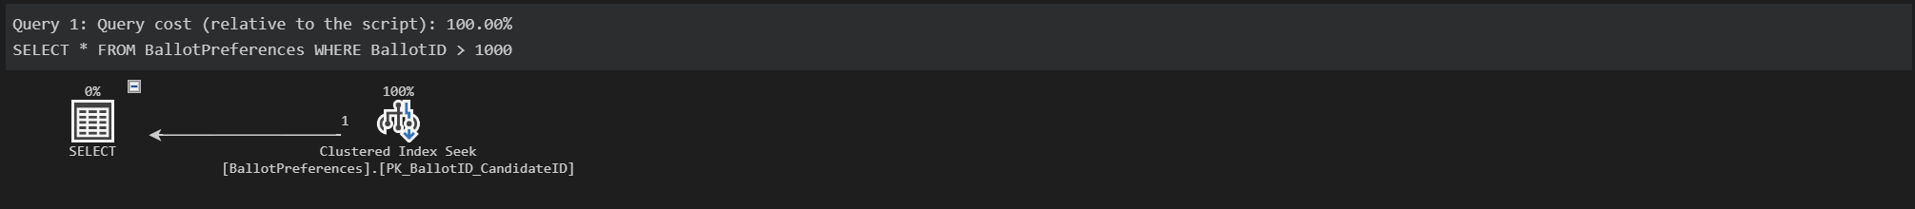
- The optimiser still uses full table scan using clustered index scan as the small amount of data in the table with similar estimated CPU cost and IO cost

Partition Joins
When the BallotPreferences table is joined with another table and partitioned by BallotID, SQL Server can perform the partition-wise joins operation within the partitions that match the partitioning scheme. This means that only the partitions with matching BallotID values from both tables are joined, rather than scanning all data in the tables and reducing the join overhead.
For example,

SELECT BP.BallotID, BP.CandidateID, B.ElectionEventID FROM BallotPreferences BP
JOIN Ballot B ON BP.BallotID = B.BallotID WHERE BP.BallotID = 1200;

- SQL Server performs the join operation between BallotPreferences table and Ballot table within BallotID value exactly 1200 corresponding to the partition 1000-1499.
- This reduces the join workload by limiting it to matching partitions, making the join operation more efficient and faster.
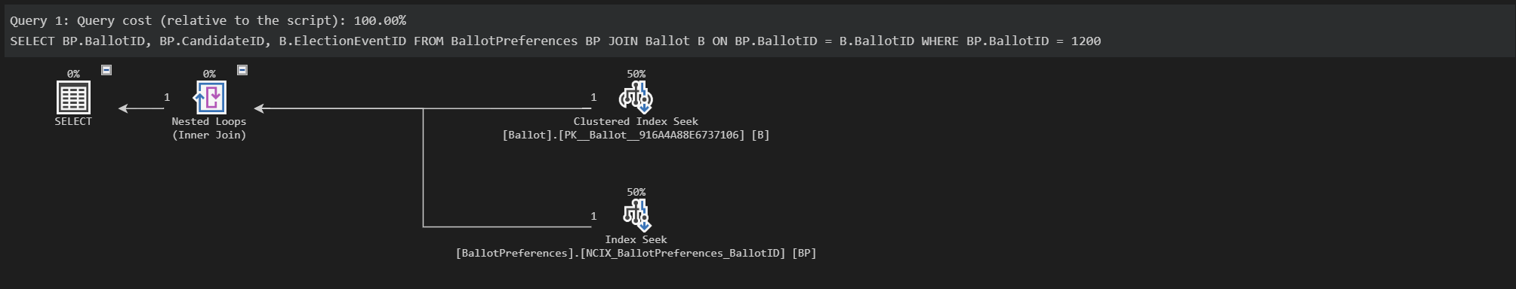
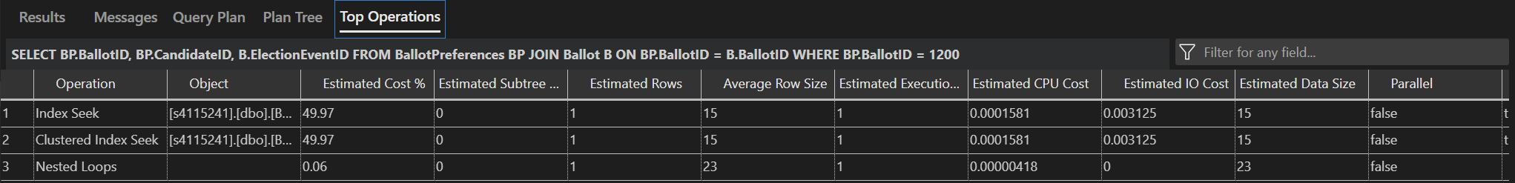
- The optimiser uses the index seek and clustered index seek as the partition has been implemented with reduced CPU cost and IO cost and distributed workloads.

Parallel SQL Execution
When a query filters by BallotID and requires multiple partitions working in parallel, SQL Server can also leverage parallel execution when querying or processing multiple partitions.
For example,

SELECT BallotID, COUNT(*) FROM BallotPreferences
WHERE BallotID BETWEEN 100 AND 900 GROUP BY BallotID;

- SQL Server identifies that the query involves multiple partitions and executes the query in parallel, with different processors or threads working on BallotID ranges between 100 and 900 (0–499 and 500–999) partitions simultaneously.
- This parallel execution speeds up query processing by distributing the workload and reducing the time required to retrieve and process the data.
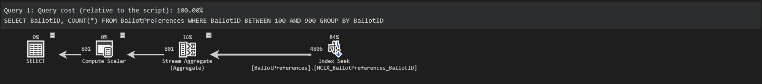
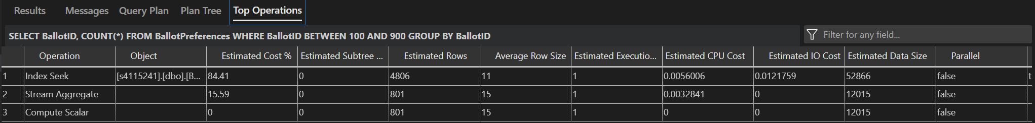
- The optimiser uses the index seek as the partition has been implemented with reduced CPU cost and IO cost and distributed workloads.

IssuanceRecord (ElectionEventID)
CREATE PARTITION FUNCTION pfIssuanceRecordElectionEventID (BIGINT)
AS RANGE RIGHT FOR VALUES (20220000000, 20250000000, 20280000000, 20310000000, 20340000000);

CREATE PARTITION SCHEME psIssuanceRecordElectionEventIDRange
AS PARTITION pfIssuanceRecordElectionEventID TO ([PRIMARY], [PRIMARY], [PRIMARY], [PRIMARY], [PRIMARY], [PRIMARY]);

-- Create a non-clustered index on the IssuanceRecord table using the partition scheme
CREATE NONCLUSTERED INDEX NCIX_IssuanceRecord_ElectionEventID
ON IssuanceRecord (ElectionEventID)
ON psIssuanceRecordElectionEventIDRange (ElectionEventID);
The pfIssuanceRecordElectionEventID partition function divides the IssuanceRecord table into partitions based on the year or first 4 digits of the ElectionEventID. This results in 4 partitions, each corresponding to a specific range of big ints from 20220000000, 20250000000, 20280000000, 20310000000, and 20340000000
The psIssuanceRecordElectionEventIDRange partition scheme maps the table data based on the partition from pfIssuanceRecordElectionEventID and nonclustered index NCIX_IssuanceRecord_ElectionEventID to ease the optimiser in accessing the partitions queried.
The partition is done using range partition since it is the only method that is available for the SQL server. Hence, this data partition is configured this way because of the convenience when partitioning based on the election year and it can contain a large number of voters in the IssuanceRecord table.
Partition Pruning
When a query filters by ElectionEventID, SQL Server uses the partition function to identify which partitions contain the data that matches the filter criteria. Only those partition years will be accessed, reducing the data scanned.
For example,

SELECT VoterID, PollingStation FROM IssuanceRecord
WHERE ElectionEventID = (
SELECT MAX(ElectionEventID) FROM IssuanceRecord
WHERE ElectionEventID < 20250000000
);

- SQL Server identifies that ElectionEventID query filter, containing the last election ID from 2022 which corresponds to a specific partition. The optimiser scans only the election IDs from 2022 partition and prunes out all other partitions.
- The result of this partition is that targeted scanning reduces computing costs and execution time and improves query performance by avoiding scanning unrelated partitions.
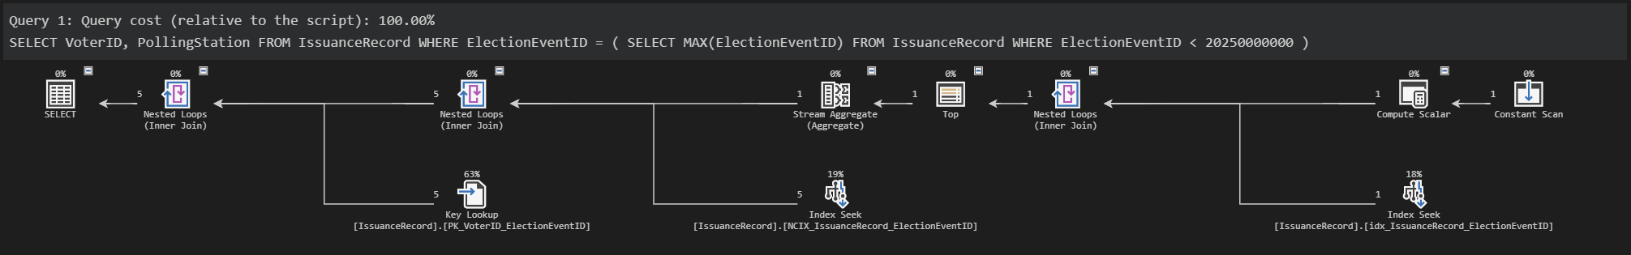
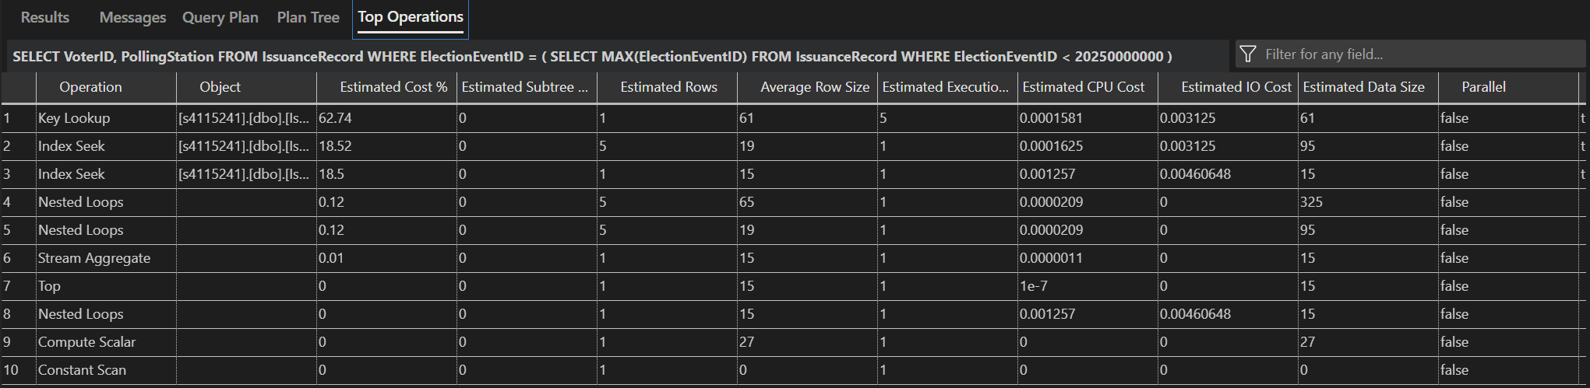
- The optimiser uses the index seek and key lookup as the partition has been implemented with reduced CPU cost and IO cost and distributed workloads.

Partition Joins
When the IssuanceRecord table is joined with another table and partitioned by ElectionEventID, SQL Server will execute the join operation within the partitions that match the partitioning scheme. This means that only the partitions with matching ElectionEventID values from both tables are joined, rather than scanning all data in the tables.
For example,

SELECT IR.VoterID, IR.IssueDate, VR.FirstName, VR.LastName FROM IssuanceRecord IR
JOIN VoterRegistry VR ON IR.VoterID = VR.VoterID WHERE IR.ElectionEventID = 20220521;

- SQL Server performs the join operation between IssuanceRecord table and VoterRegistry table within election IDs from 2022 corresponding partitions.
- This reduces the join workload to relevant subsets of data by limiting it to matching partitions, speeding up the join operation process and making it more efficient.
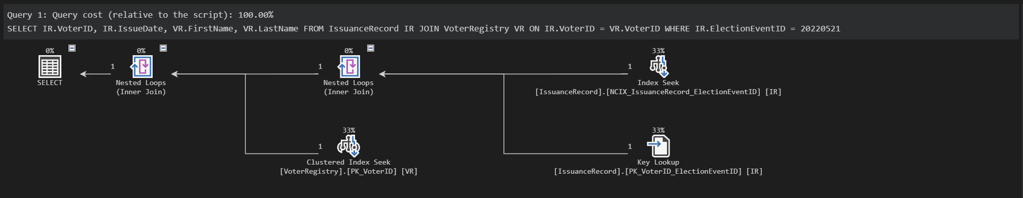
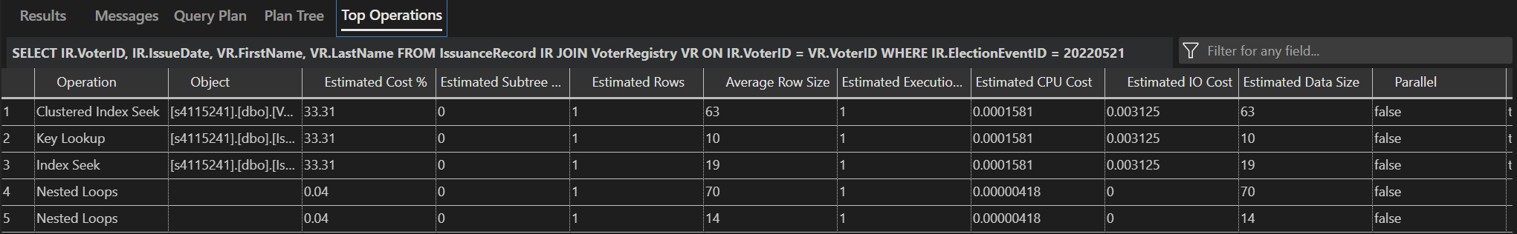
- The optimiser uses the index seek, key lookup, and clustered index seek as the partition has been implemented with reduced CPU cost and IO cost and distributed workloads.

Parallel SQL Execution
When a query filters by ElectionEventID and requires multiple partitions working in parallel, SQL Server can also leverage parallel execution when querying or processing multiple partitions simultaneously, reducing execution time.
For example,

SELECT VoterID, IssueDate, PollingStation FROM IssuanceRecord
WHERE ElectionEventID BETWEEN 20190000000 AND 20220000000;

- SQL Server identifies that the query involves multiple partitions and executes the query in parallel, with different processors or threads working on the '2019' and '2022' partitions simultaneously.
- This parallel execution speeds up query processing by distributing the workload and reducing the time required to retrieve and process the data.
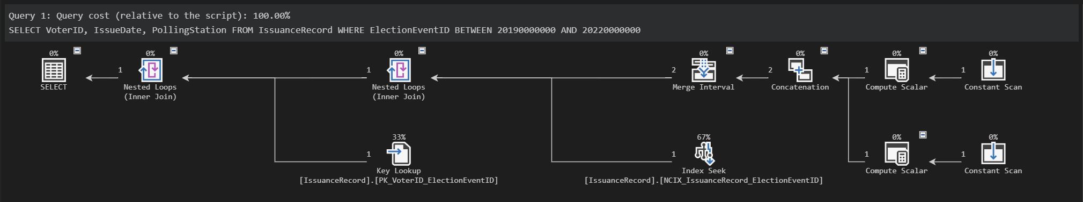
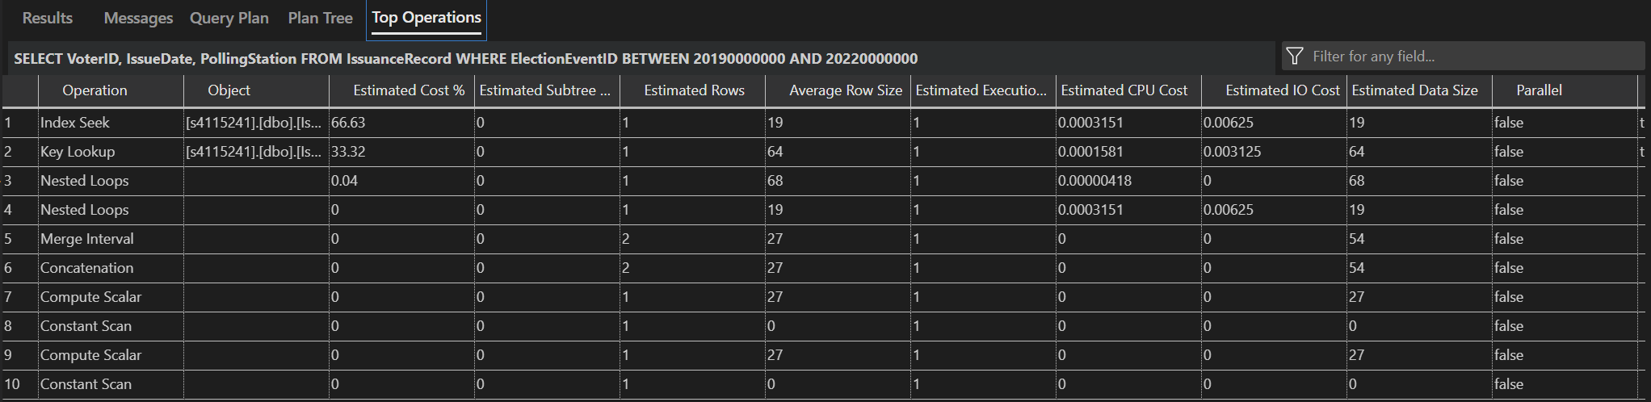
- The optimiser uses the index seek and key lookup as the partition has been implemented with reduced CPU cost and IO cost and distributed workloads.

Conclusion Task 3
From the query plan examples, we can see that the results utilize the nonclustered index linked to the partitions corresponding to the tables. Therefore, partitioning in database is very important and useful for futureproofing the overall database to be used for a long period of time. It is crucial to learn about the database schema in order to acknowledge what aspects of the database or tables can be partitioned into efficiently and effectively. The database administrator must learn about the data to provide the best solutions to optimize the overall database. With a variety of other partition methods, the database can be further optimized to give better performance in shorter execution time and smaller computing costs when handling a large amount of data. Therefore, partitioning simulations can be further seen and learned to have the best optimized database for years to come.
References Task 3
OpenAI (2024) ChatGPT (September 2024 GPT-4) [Large language model], accessed 15 September 2024. https://chatgpt.com/share/66e68fc1-0150-8007-b208-5ae090f946f3
OpenAI (2024) ChatGPT (September 2024 GPT-4) [Large language model], accessed 15 September 2024. https://chatgpt.com/share/66e68fe0-e690-8007-9519-1d9c94e9d7f0
TASK 4
CREATE FUNCTION previouslyVoted(
@ElectionEventID BIGINT,
@DivisionName VARCHAR(255),
@VoterID INT
)
RETURNS BIT
AS
BEGIN
DECLARE @Voted BIT;

-- Validate ElectionEventID exists in ElectionEvent table
IF NOT EXISTS (
SELECT 1
FROM ElectionEvent
WHERE ElectionEventID = @ElectionEventID
)
BEGIN
RETURN NULL;
END

-- Validate DivisionName in ElectoralDivision table
IF NOT EXISTS (
SELECT 1
FROM ElectoralDivision
WHERE DivisionName = @DivisionName
)
BEGIN
RETURN NULL;
END

-- Validate VoterID in VoterRegistry table
IF NOT EXISTS (
SELECT 1
FROM VoterRegistry
WHERE VoterID = @VoterID
)
BEGIN
RETURN NULL;
END

-- Check if the voter exists in the VoterRegistry for the specified ElectionEventID and DivisionName
IF NOT EXISTS (
SELECT 1
FROM VoterRegistry
WHERE
VoterID = @VoterID
AND ElectionEventID = @ElectionEventID
AND DivisionName = @DivisionName
)
BEGIN
RETURN NULL;
END

-- Check if the voter has issued a vote in the specified election
IF EXISTS (
SELECT 1
FROM IssuanceRecord
WHERE
ElectionEventID = @ElectionEventID
AND VoterID = @VoterID
)
BEGIN
SET @Voted = 1;
END
ELSE
BEGIN
SET @Voted = 0;
END

RETURN @Voted;
END;

DECLARE @Voted BIT;

-- Call the function
SET @Voted = dbo.previouslyVoted(20220521149, 'Sydney', 1);

-- Check for errors
IF @Voted IS NULL
BEGIN
SELECT 'Validation error occurred.';
END
ELSE IF @Voted = 1
BEGIN
SELECT 'ALREADY voted';
END
ELSE
BEGIN
SELECT 'NOT voted';
END
The previouslyVoted() function stores Data Query Language (DQL) to check whether a voter has voted beforehand earlier in the election. It has ElectionEventID, DivisionName, and VoterID as the parameters to check specific voters in a specific location, so the function can narrow down its search to the parameters. The function will return the BIT data type which has 1 (True) or 0 (False) values as a replacement for the Boolean data type since SQL Server does not Boolean data type.
First, the function declares the Voted BIT output to be generated at the end of the function. Then, the function validates all the inputs before going to the main query. The first validation is on ElectionEventID as the first user input. It checks the ElectionEvent table to see if the value exists. If it does not exist, it will return NULL. The second validation is on DivisionName as the second user input. It checks the ElectoralDivision table to see if the value exists. If it does not exist, it will return NULL. The third validation is on VoterID as the third user input. It checks the VoterRegistry table to see if the value exists. If it does not exist, it will return NULL. Final validation is checking whether the voter matches in the VoterRegistry table using VoterID along with the corresponding ElectionEventID and DivisionName. This is to ensure the voter has registered according to their whereabouts.
Finally, the main function will run after validation has been gone through. The select query checks whether the voter has voted by scanning the IssuanceRecord table which matches the ElectionEventID and VoterID, since the table does not have DivisionName values. If the value matches the criteria, it will set the Voted BIT to 1. If the value does not match, it will set the Voted BIT to 0. These values will be displayed in the query when the function is called.
To call the function, we need to declare the Voted BIT value as the output after running all queries in the function. Call the function and input the designated parameters. Next, the query will check through the validations and the main query whether the voter has voted or not. The Voted value begins with NULL which will print the message “Validation error occurred”. This indicates that there has been a validation error in the user input and the user needs to recheck the input values. Next, if the Voted value equals 1, it indicates that the voter has already voted which the data is in the IssuanceRecord table. Otherwise, if it equals 0, it indicates that the voter has not yet voted, and the data is not in the IssuanceRecord table.

References Task 4
OpenAI (2024) ChatGPT (September 2024 GPT-4) [Large language model], accessed 15 September 2024. https://chatgpt.com/share/66e6904d-1348-8007-bb8d-ec92b28d756f
TASK 5
CREATE PROCEDURE primaryVoteCount
@ElectionEventID BIGINT,
@DivisionName VARCHAR(255)
AS
BEGIN
-- Declare a variable for the round number
DECLARE @RoundNo INT = 1;

-- Check if the DivisionName exists for the given ElectionEventID
IF NOT EXISTS (
SELECT 1
FROM Ballot B
JOIN ElectionEvent EE ON B.ElectionEventID = EE.ElectionEventID
WHERE EE.DivisionName = @DivisionName
AND B.ElectionEventID = @ElectionEventID
)
BEGIN
RAISERROR('The specified DivisionName does not match the ElectionEventID.', 16, 1);
RETURN;
END

-- Step 1: Delete existing results for this round (if any) to avoid duplicates
DELETE FROM PreferenceTallyPerRoundPerCandidate WHERE RoundNo = @RoundNo;
DELETE FROM PrefCountRound WHERE RoundNo = @RoundNo;

-- Create a temporary table to hold counts
CREATE TABLE #TempCounts (
CandidateID INT,
FirstPreferences INT
);

-- Insert first preference counts into the temporary table, count only first preferences
INSERT INTO #TempCounts (CandidateID, FirstPreferences)
SELECT
BP.CandidateID,
COUNT(*) AS FirstPreferences
FROM
Ballot B
INNER JOIN BallotPreferences BP ON B.BallotID = BP.BallotID
WHERE
B.ElectionEventID = @ElectionEventID
AND BP.PreferenceNumber = 1
GROUP BY
BP.CandidateID;

-- Insert results into PrefCountRecord table
INSERT INTO PrefCountRound (ElectionEventID, RoundNo, CountStatus)
VALUES
(@ElectionEventID, @RoundNo, 'Completed');

-- Insert results into PreferenceTallyPerRoundPerCandidate table
INSERT INTO PreferenceTallyPerRoundPerCandidate (ElectionEventID, RoundNo, CandidateID, PreferenceTally)
SELECT
@ElectionEventID,
@RoundNo,
CandidateID,
FirstPreferences
FROM
#TempCounts;

-- Drop the temporary table
DROP TABLE #TempCounts;
END;
GO

-- Example values
DECLARE @ElectionEventID BIGINT = 20220521245;
DECLARE @DivisionName VARCHAR(255) = 'Perth';

-- Execute the stored procedure
EXEC primaryVoteCount @ElectionEventID, @DivisionName;

SELECT * FROM PreferenceTallyPerRoundPerCandidate;
SELECT * FROM PrefCountRound;
SELECT SUM(PreferenceTally) AS TotalVotes FROM PreferenceTallyPerRoundPerCandidate WHERE RoundNo = 1;

The primaryvoteCount() stored procedure stores Data Definition Language (DDL), Data Manipulation Language (DML), and Data Query Language (DQL) to count all the first preference candidates of each vote to determine the leading candidate for the initial round. It has ElectionEventID and DivisionName as the parameters to calculate each first-preference vote based on the location of the votes. The procedure will return new data stored in 2 tables consisting of all first preference votes in a specific division stored in the PreferenceTallyPerRoundPerCandidate table and whether there is an eliminated candidate from the counting round stored in the PrefCountRound table.
First, the procedure declares the round number which is 1 as the initial counting round. Next, it checks the user inputs whether the ElectionEventID and Division name matches the joining Ballot table and ElectionEvent table. If the inputs are not correct, it will print an error message “The specified DivisionName does not match the ElectionEventID.”
To start the counting process, the procedure deletes any data that has the same RoundNo to prevent any data duplication for both tables when executing the procedure. Next, the procedure creates a temporary table to store the first preferences counted. This is intentionally done to prevent any duplication when inserting it into the designated table. Then, the select query runs to count the first preference votes for each candidate to see how many first votes each candidate gets and insert the data into the temporary table.
After the counting process, the procedure inserts initial data to the PrefCountRound table with the ElectionEventID input, declared RoundNo, and no eliminated candidate as it is the first round. Finally, the counted data is stored in the PreferenceTallyPerRoundPerCandidate table to be visualized and further counted for the next round along with the ElectionEventID and the RoundNo. To clean up the unnecessary data, the procedure drops the temporary table which will not be used in further queries.
To execute the procedure, the user must input the correct ElectionEventID and DivisionName so the counting process will be initialized, otherwise it will print the error statement. To visualise the tables and the total first preference votes, the select queries can be run to determine whether the counting process is correct or not.

References Task 5
OpenAI (2024) ChatGPT (September 2024 GPT-4) [Large language model], accessed 15 September 2024. https://chatgpt.com/share/66e69083-4a70-8007-be20-708c68b69f5c

